Add code section

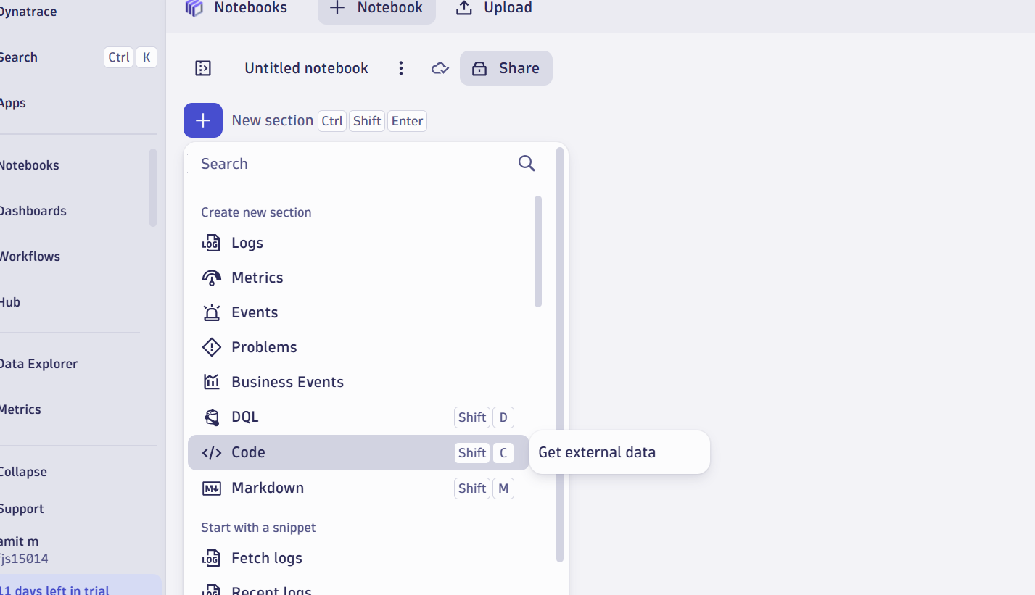

Use this json file

fetch('http://api.open-notify.org/iss-now.json', {

headers: {

'Accept': 'application/json'

}

})

.then(response => response.text())

.then(text => console.log(text))

Run and it fails

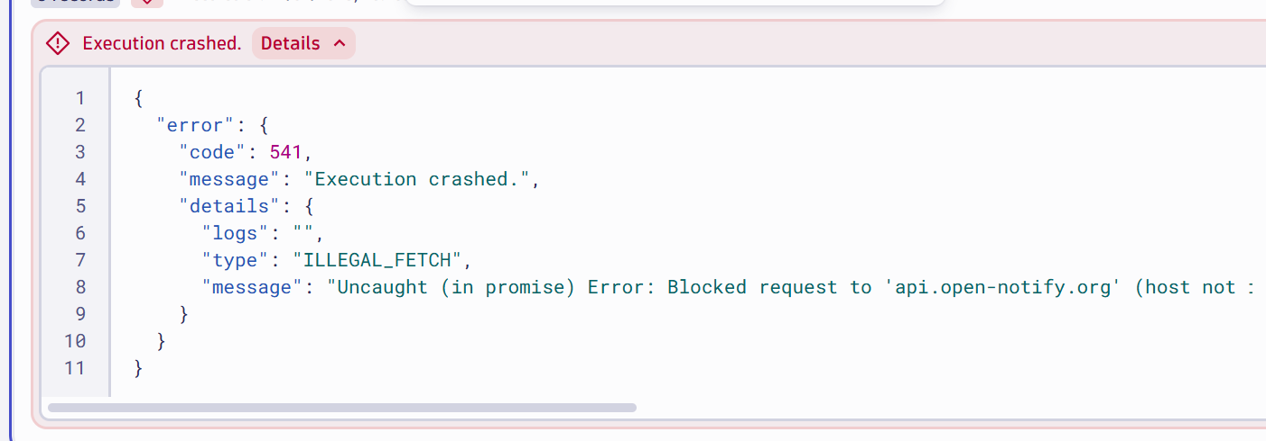

App 🡪setting option

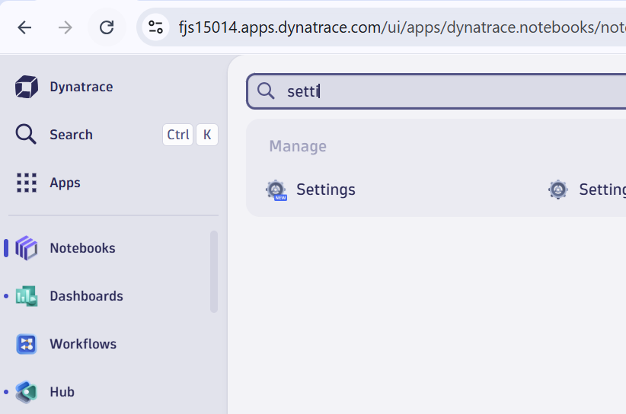

Click on General 🡪external request

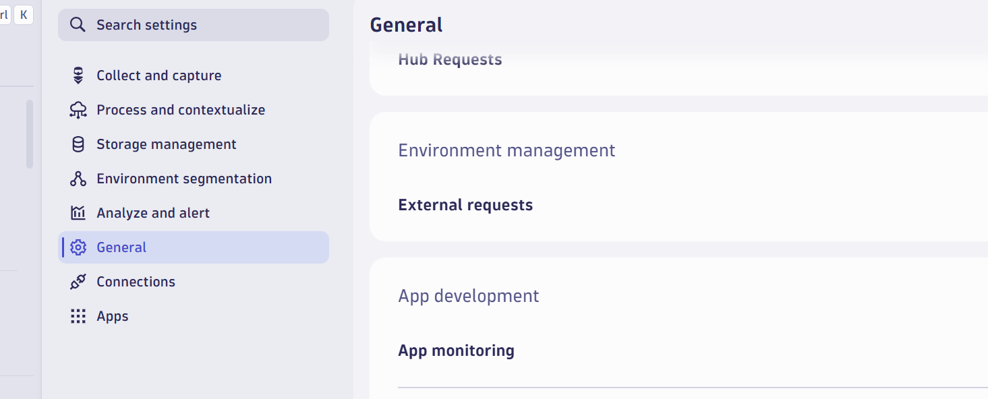

Click on confirm

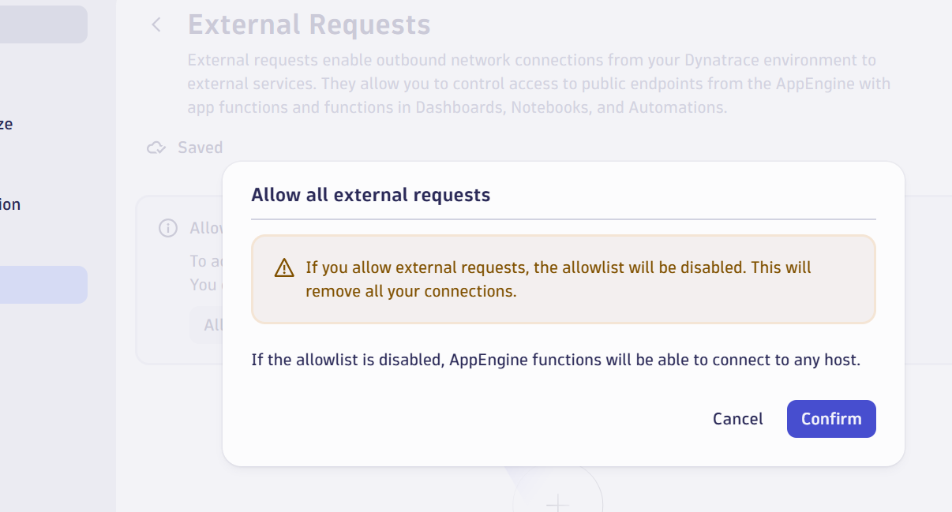

Now rerun the notebook

